Below is the screenshot when we are selecting attributes randomly and splitting

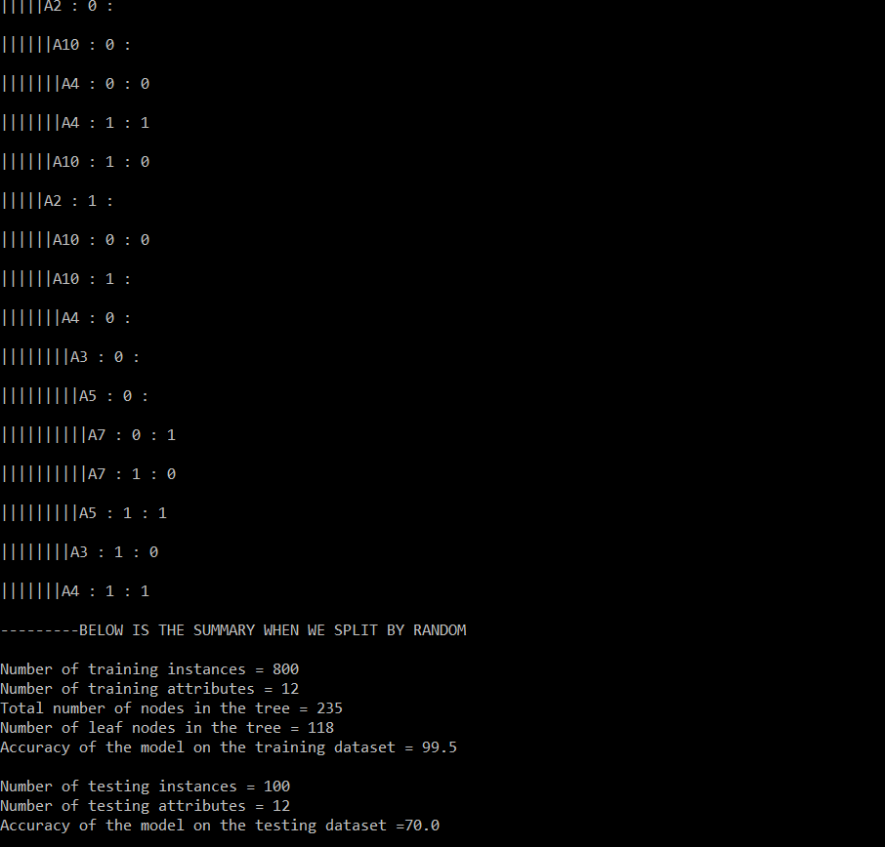

Below is the screenshot when we are splitting with ID3

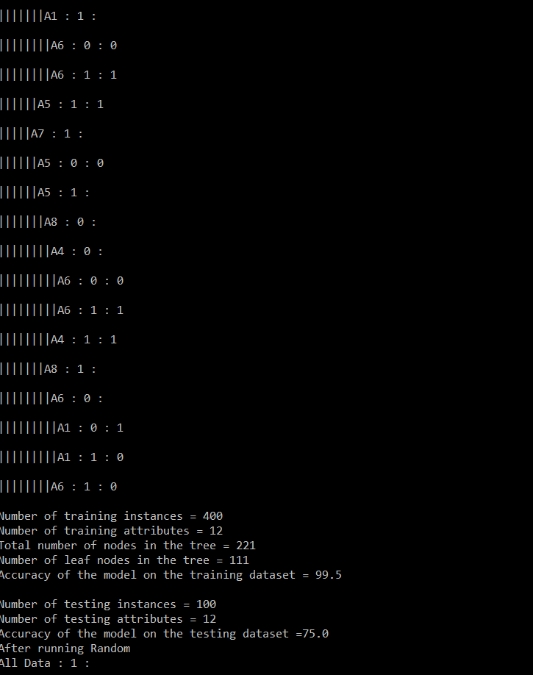

Second Run –

When we select randomly for splitting

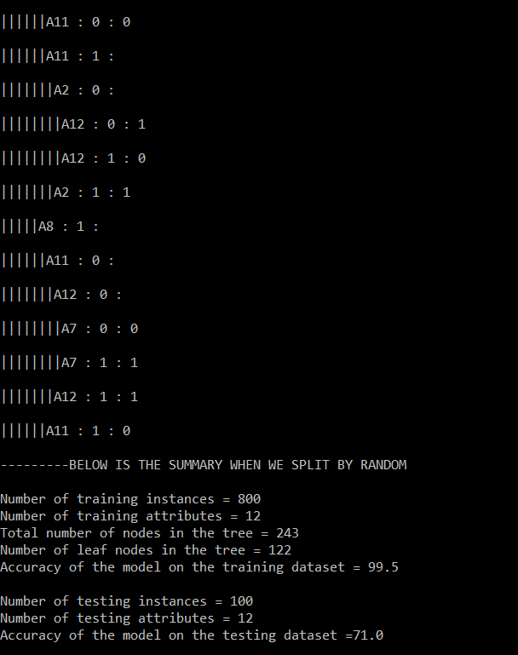

When using ID3

